# Updated model (14K dataset Unet)

Note:

The comparison below shows input images on the left and output image (inference result) on the right. The model is created with the assumption that the deblur condition of the satellite image are similar to the provided input images and thus might vary depending on how different the actual input images are, from those that we have fed the model with.

# Trial model (Unet )

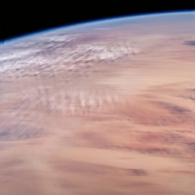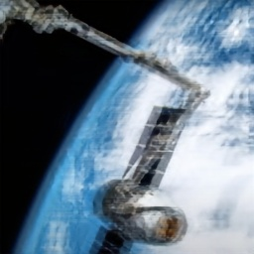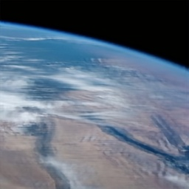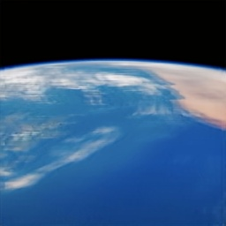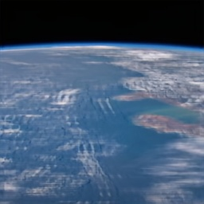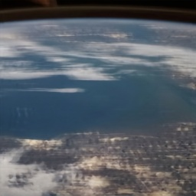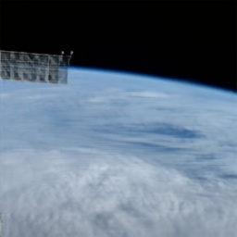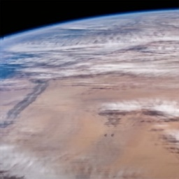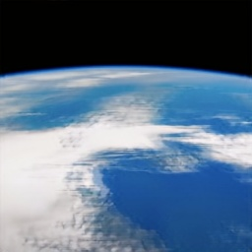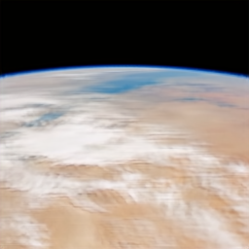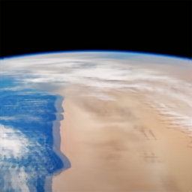

# Trial model (GAN)

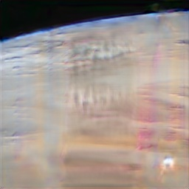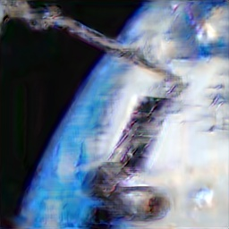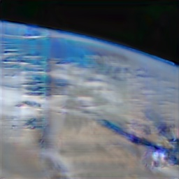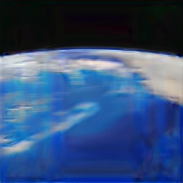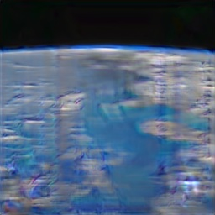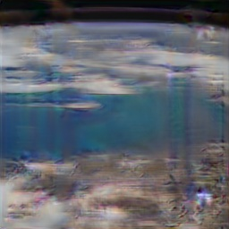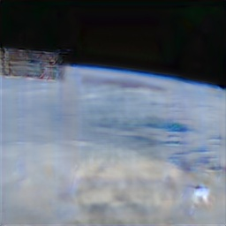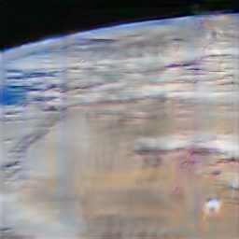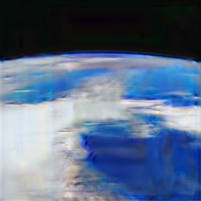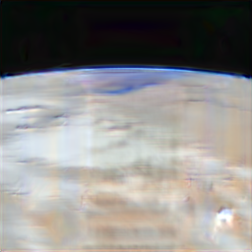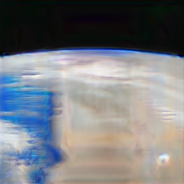

# Old model (Resize)

Test 1

Test Result

Test Result

Test Result

Test 4

Test Result

Test 5

Test Result

Test 6

Test Result

Test Result

Test Result

Test Result

Test Result

Test Result

